NAME: OLADIPUPO ROLAND FAMILUA
STUDENT ID: 2326310
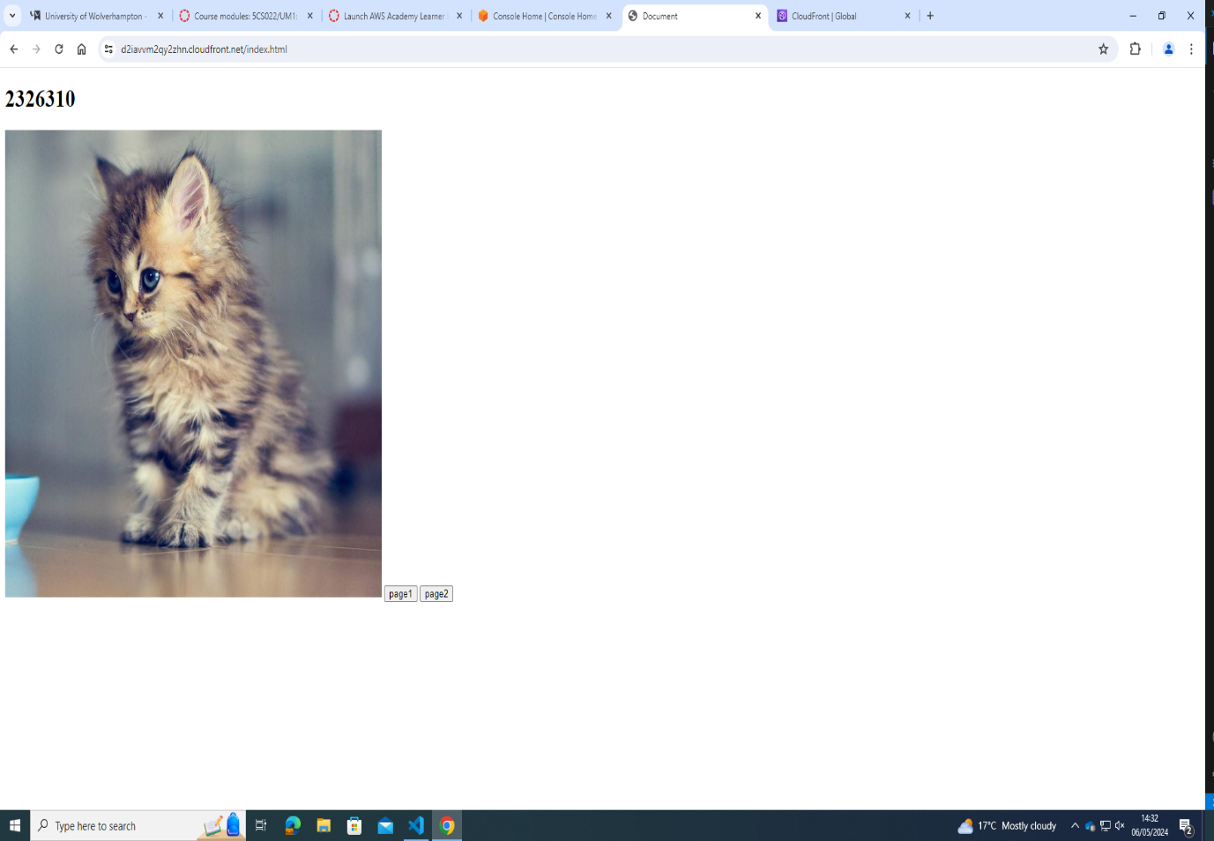
INDEX.HTML
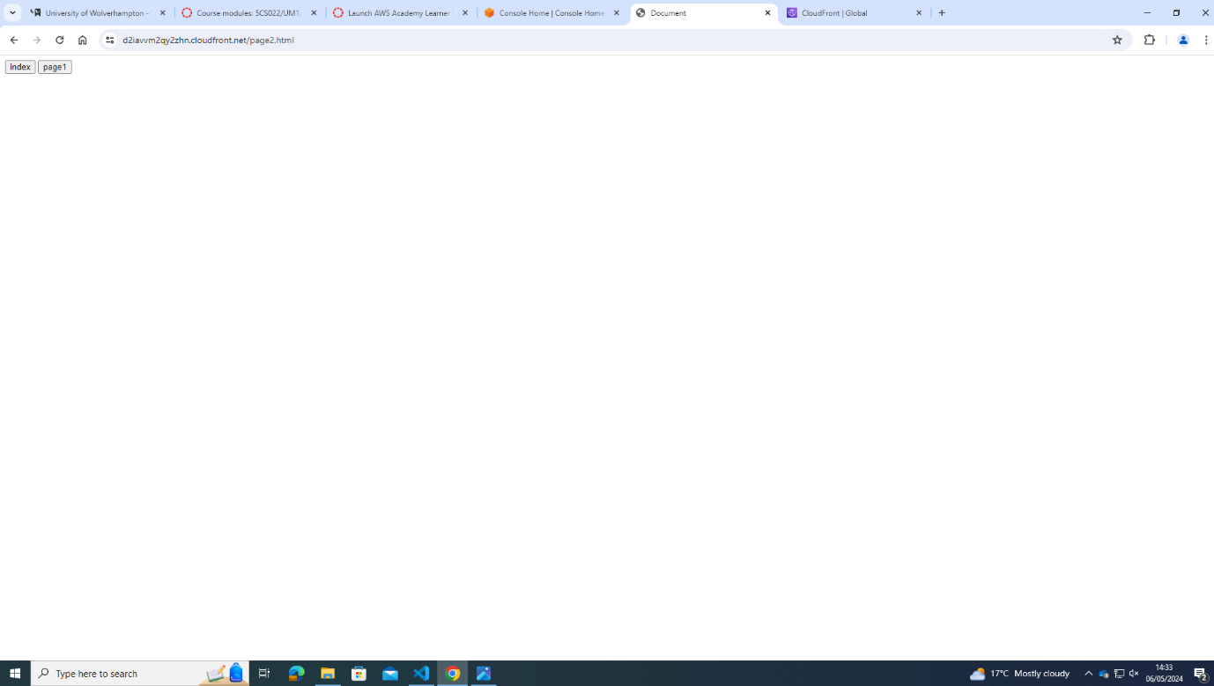
PAGE1.HTML
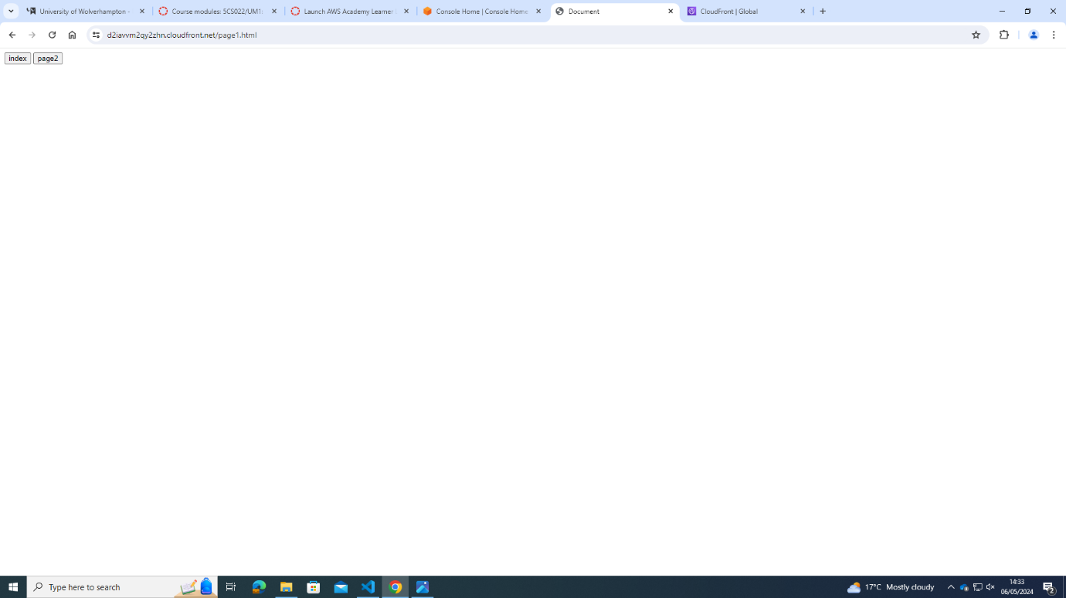
PAGE2.HTML

